**UNIT 3**

**Pro 1: Create shape class having area as must override function. Derive rectangle, triangle, square class based from this class.**

**Class Code:**

**using System;**

**using System.Collections.Generic;**

**using System.Linq;**

**using System.Text;**

**namespace U3P1**

**{**

**class Class1**

**{**

**}**

**abstract class Shape**

**{**

**int h, w, l;**

**public int height**

**{**

**get**

**{**

**return h;**

**}**

**set**

**{**

**h = value;**

**}**

**}**

**public int width**

**{**

**get { return w; }**

**set { w = value; }**

**}**

**public int length**

**{**

**get { return l; }**

**set { l=value; }**

**}**

**public abstract double area();**

**}**

**class clsrect : Shape**

**{**

**public override double area()**

**{ return (height*width);}**

**}**

**class clstri : Shape**

**{**

**public override double area()**

**{ return (0.5 * height * length); }**

**}**

**class clssquare : Shape**

**{**

**public override double area()**

**{ return (height * height); }**

**}**

**}**

**Form code:**

**using System;**

**using System.Collections.Generic;**

**using System.ComponentModel;**

**using System.Data;**

**using System.Drawing;**

**using System.Linq;**

**using System.Text;**

**using System.Windows.Forms;**

**namespace U3P1**

**{**

**public partial class Form1 : Form**

**{**

**public Form1()**

**{**

**InitializeComponent();**

**}**

**private void btnCalculate_Click(object sender, EventArgs e)**

**{**

**clsrect r = new clsrect();**

**r.height= Convert.ToInt16(textBoxh1.Text);**

**r.width = Convert.ToInt16(textBoxw1.Text);**

**labOutRect.Text = r.area().ToString();**

**clstri t = new clstri();**

**t.height = Convert.ToInt16(textBoxh2.Text);**

**t.length = Convert.ToInt16(textBoxL.Text);**

**labOutTri.Text = t.area().ToString();**

**clssquare s = new clssquare();**

**s.height = Convert.ToInt16(textBoxh3.Text);**

**labOutSq.Text = s.area().ToString();**

**}**

**private void btnClr_Click(object sender, EventArgs e)**

**{**

**textBoxh1.Clear();**

**textBoxh2.Clear();**

**textBoxh3.Clear();**

**textBoxL.Clear();**

**textBoxw1.Clear();**

**labOutRect.Text = "";**

**labOutSq.Text = "";**

**labOutTri.Text = "";**

**}**

**}**

**}**

**OUTPUT:**

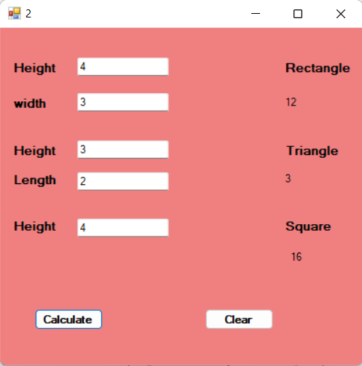

**Pro 2: Write a program to create Person. Make at least three properties and one method “show detail” of this class. Now inherit class student and faculty from class Person and override method “show detail”. Create objects of Student and Faculty class and call show detail function for both objects to show details in appropriate text boxes.**

**Class Code:**

**using System;**

**using System.Collections.Generic;**

**using System.Linq;**

**using System.Text;**

**namespace U3P2**

**{**

**class Person**

**{**

**String cls, div, sub;**

**public String pcls**

**{**

**get{ return cls; }**

**set { cls = value; }**

**}**

**public String pdiv**

**{**

**get { return div; }**

**set { div = value; }**

**}**

**public String psub**

**{**

**get { return sub; }**

**set { sub = value; }**

**}**

**public virtual String showdetail()**

**{**

**return pcls + pdiv + psub;**

**}**

**}**

**class Student : Person**

**{**

**public override String showdetail()**

**{**

**return "Student Class:" + pcls + "\n" + "Student Div:" + pdiv + "\n" + "Student Subject:" + psub;**

**}**

**}**

**class Faculty : Person**

**{**

**public override String showdetail()**

**{**

**return "Faculty Class:" + pcls +"\n" + "Faculty Subject:" + psub;**

**}**

**}**

**}**

**Form Code:**

**using System;**

**using System.Collections.Generic;**

**using System.ComponentModel;**

**using System.Data;**

**using System.Drawing;**

**using System.Linq;**

**using System.Text;**

**using System.Windows.Forms;**

**namespace U3P2**

**{**

**public partial class Form1 : Form**

**{**

**public Form1()**

**{**

**InitializeComponent();**

**}**

**private void button1_Click(object sender, EventArgs e)**

**{**

**Student s1 = new Student();**

**s1.pcls = textBox1.Text;**

**s1.pdiv = textBox2.Text;**

**s1.psub = textBox3.Text;**

**label6.Text = s1.showdetail();**

**}**

**private void button2_Click(object sender, EventArgs e)**

**{**

**Faculty f1 = new Faculty();**

**f1.pcls = textBox1.Text;**

**f1.psub = textBox3.Text;**

**label7.Text = f1.showdetail();**

**}**

**}**

**}**

**OUTPUT:**

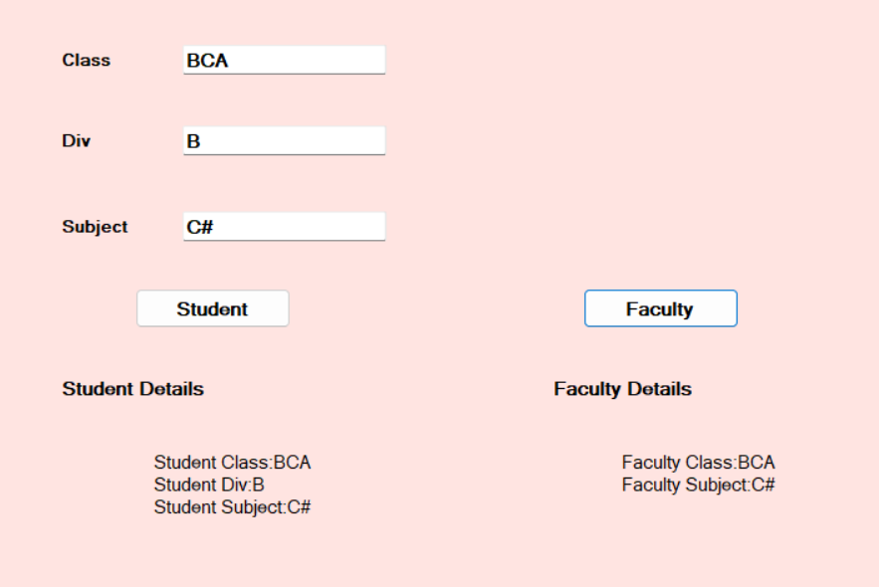

**Pro 3: Write a program to implement the class Employee. Show Constructor Overloading.**

**Class Code:**

**using System;**

**using System.Collections.Generic;**

**using System.Linq;**

**using System.Text;**

**namespace U3P3**

**{**

**class Employee**

**{**

**int no, salary;**

**String name, dept;**

**public Employee() { }**

**public int disNo(int n)**

**{**

**no = n;**

**return Convert.ToInt32(no);**

**}**

**public int disSal(int s)**

**{**

**salary = s;**

**return Convert.ToInt32(salary);**

**}**

**public Employee(String n, String d)**

**{**

**name = n;**

**dept = d;**

**}**

**public String display()**

**{**

**return "\nEmployee Name:" + name + "\nEmployee Dept:" + dept;**

**}**

**}**

**}**

**Form Code:**

**using System;**

**using System.Collections.Generic;**

**using System.ComponentModel;**

**using System.Data;**

**using System.Drawing;**

**using System.Linq;**

**using System.Text;**

**using System.Windows.Forms;**

**namespace U3P3**

**{**

**public partial class Form1 : Form**

**{**

**public Form1()**

**{**

**InitializeComponent();**

**}**

**private void button1_Click(object sender, EventArgs e)**

**{**

**int a = Convert.ToInt32(textBox1.Text);**

**int b = Convert.ToInt32(textBox3.Text);**

**Employee e1 = new Employee();**

**label5.Text = Convert.ToString(e1.disNo(a));**

**label7.Text = Convert.ToString(e1.disSal(b));**

**}**

**private void button2_Click(object sender, EventArgs e)**

**{**

**Employee e2 = new Employee(textBox2.Text,textBox4.Text);**

**label6.Text = e2.display();**

**}**

**}**

**}**

**OUTPUT:**

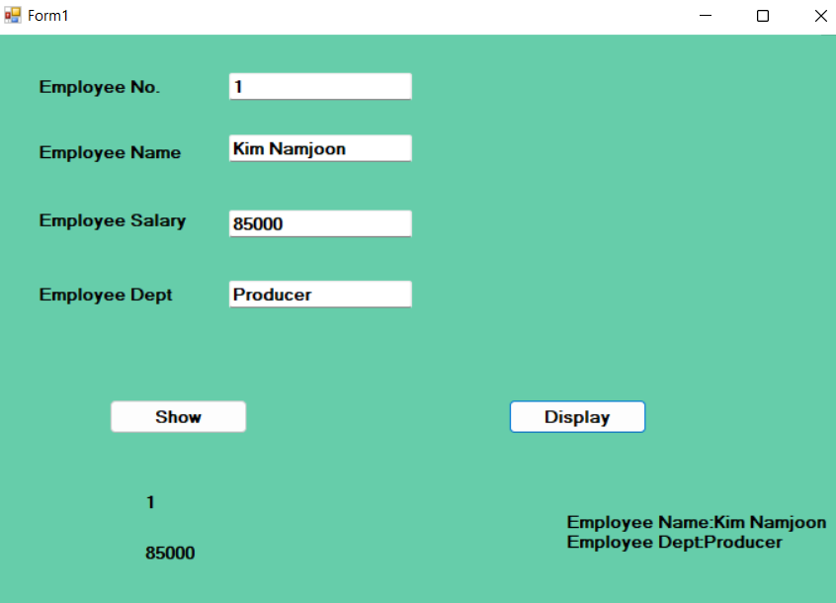

**Pro 4: Write a program to implement the class Book. Show Method Overloading.**

**Class Code:**

**using System;**

**using System.Collections.Generic;**

**using System.Linq;**

**using System.Text;**

**namespace U3P4**

**{**

**class Book**

**{**

**int id, no, pr;**

**String title, author, pub;**

**public int display(int i,int n,int p)**

**{**

**id = i; no = n; pr = p;**

**return Convert.ToInt32("\n Book id=" + id + "\n Book PageNo.=" + no + "\n Book Price=" + pr);**

**}**

**public String display(String t,String a,String p)**

**{**

**title = t; author = a; pub = p;**

**return "\n Book Title=" + title + "\n Book Author=" + author + "\n Book Publisher=" + pub;**

**}**

**}**

**}**

**Form Code:**

**using System;**

**using System.Collections.Generic;**

**using System.ComponentModel;**

**using System.Data;**

**using System.Drawing;**

**using System.Linq;**

**using System.Text;**

**using System.Windows.Forms;**

**namespace U3P4**

**{**

**public partial class Form1 : Form**

**{**

**public Form1()**

**{**

**InitializeComponent();**

**}**

**private void button1_Click(object sender, EventArgs e)**

**{**

**Book b1 = new Book();**

**label7.Text = b1.display(textBox1.Text, textBox2.Text, textBox3.Text);**

**label8.Text = b1.display(textBox4.Text, textBox5.Text, textBox6.Text);**

**}**

**}**

**}**

**OUTPUT:**

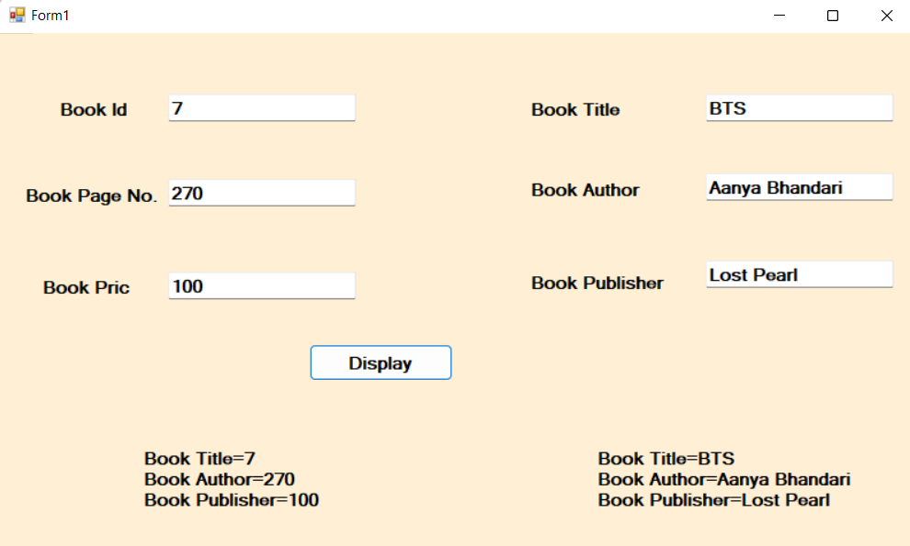

**Pro 5: Create an Invoice application in which user enters the Customer name, description, unit price and quantity for the item order, then click the add item button. The application calculates the order total by multiplying the unit price by the quantity. And calculates a discount based on the order total. The user can then add another item to order by using all information.**

**Code:**

**using System;**

**using System.Collections.Generic;**

**using System.ComponentModel;**

**using System.Data;**

**using System.Drawing;**

**using System.Linq;**

**using System.Text;**

**using System.Windows.Forms;**

**namespace U3P5**

**{**

**public partial class Form1 : Form**

**{**

**public Form1()**

**{**

**InitializeComponent();**

**}**

**private void btntext_Click(object sender, EventArgs e)**

**{**

**labTotal.Text = Convert.ToString(Convert.ToDouble(textBoxPr.Text) * Convert.ToDouble(textBoxQty.Text));**

**// labTotal.Text = Convert.ToString(amt);**

**}**

**private void btnDis_Click(object sender, EventArgs e)**

**{**

**double amt= Convert.ToDouble(labTotal.Text);**

**if( amt >= 0 && amt <=1000 )**

**labDis.Text = Convert.ToString(Convert.ToDouble(labTotal.Text)*5/100);**

**else if (amt >= 1000 && amt <= 2000)**

**labDis.Text = Convert.ToString(Convert.ToDouble(labTotal.Text) * 10 / 100);**

**else if (amt >= 2000 && amt <= 3000)**

**labDis.Text = Convert.ToString(Convert.ToDouble(labTotal.Text) * 15 / 100);**

**else**

**labDis.Text = Convert.ToString(Convert.ToDouble(labTotal.Text) * 20 / 100);**

**}**

**private void btnNet_Click(object sender, EventArgs e)**

**{**

**labNet.Text = Convert.ToString(Convert.ToDouble(labTotal.Text) - Convert.ToDouble(labDis.Text));**

**}**

**private void btnBill_Click(object sender, EventArgs e)**

**{**

**labInvo.Text += "\n"+textBoxCname.Text + "\n" + textBoxIname.Text + "\n";**

**}**

**private void btnAdd_Click(object sender, EventArgs e)**

**{**

**double s;**

**s = Convert.ToDouble(textBoxPr.Text) * Convert.ToDouble(textBoxQty.Text);**

**//textBoxCname.Enabled = false;**

**lab.Text += "\n" + textBoxIname.Text + " " + s.ToString() + "Rs";**

**}**

**}**

**}**

**OUTPUT:**

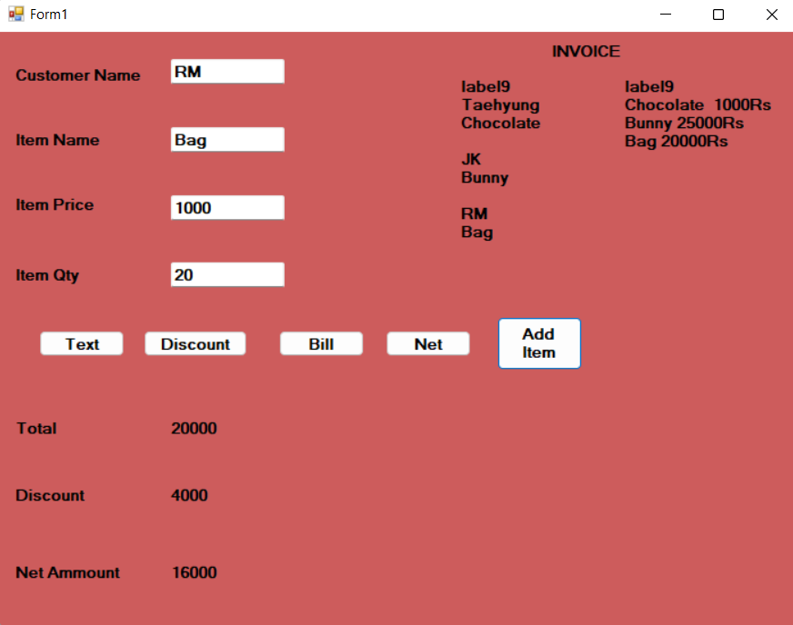

**Pro 7: Write an application , which works like a window’s explorer, using combo box and list box.**

1. **The Combo box should display the list of drives.**
2. **The list box should display the list of files and directories.**

**Code:**

**using System;**

**using System.Collections.Generic;**

**using System.ComponentModel;**

**using System.Data;**

**using System.Drawing;**

**using System.Linq;**

**using System.Text;**

**using System.Windows.Forms;**

**using System.IO;**

**namespace U3P7**

**{**

**public partial class Form1 : Form**

**{**

**public Form1()**

**{**

**InitializeComponent();**

**}**

**private void button1_Click(object sender, EventArgs e)**

**{**

**comboBox1.Items.Clear();**

**string[] drives = Directory.GetLogicalDrives();**

**comboBox1.Items.AddRange(drives);**

**}**

**private void comboBox1_SelectedIndexChanged(object sender, EventArgs e)**

**{**

**listBox1.Items.Clear();**

**String path = Convert.ToString(comboBox1.SelectedItem);**

**string [] dir = Directory.GetDirectories(path);**

**listBox1.Items.AddRange(dir);**

**}**

**private void listBox1_SelectedIndexChanged(object sender, EventArgs e)**

**{**

**listBox2.Items.Clear();**

**String path1 = Convert.ToString(listBox1.SelectedItem);**

**string[] dir1 = Directory.GetFileSystemEntries(path1);**

**listBox2.Items.AddRange(dir1);**

**}**

**private void listBox2_SelectedIndexChanged(object sender, EventArgs e)**

**{**

**listBox3.Items.Clear();**

**String path2 = Convert.ToString(listBox2.SelectedItem);**

**string[] dir2 = Directory.GetFileSystemEntries(path2);**

**listBox3.Items.AddRange(dir2);**

**}**

**}**

**}**

**OUTPUT:**

